USING THE SHARED CALENDAR
If your Group or institution is sponsoring an event that you think other ARC librarians might want to attend, get the word out by adding it to the Calendar!
ADDING AN EVENT TO THE CALENDAR
- Click on “Calendar” in the navigation bar.
- Click on the “Add Events” link.
- (Continued on next page, with accompanying screenshot image)
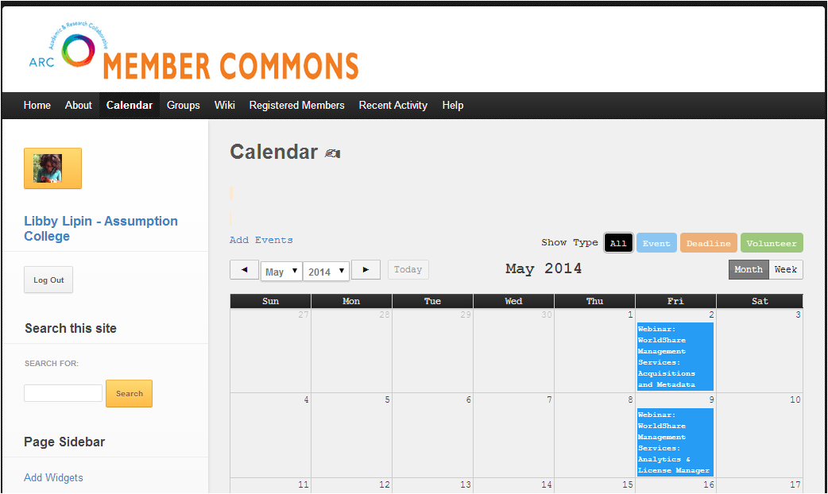

- SINGLE-click on the day your event is taking place.
- A pop-up window will appear.
  - If the window below does NOT appear, make sure your pop-up blocker is off/look for a message from your Internet browser to allow an exception for this pop-up.
- Add all the details about your event.
  - Fields in that appear in yellow with red text are required
- Click on the blue “Add” button.
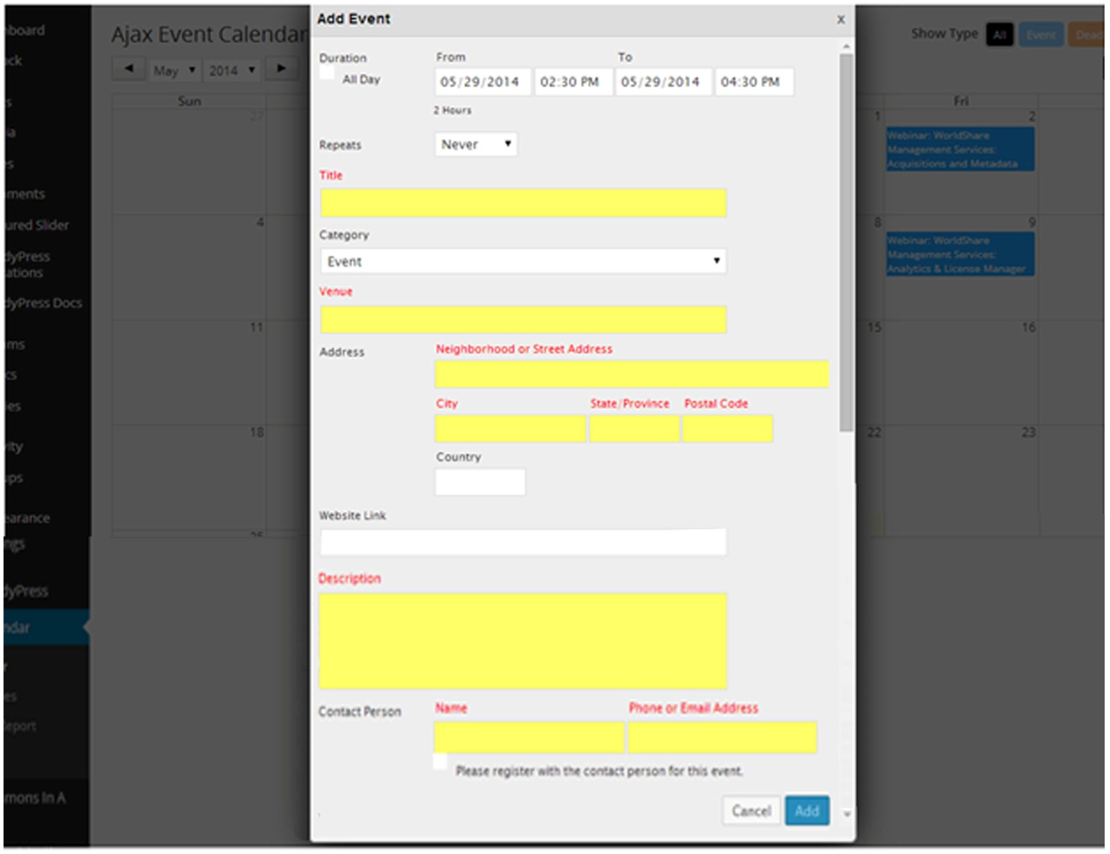
YOUR EVENT IS NOW VISIBLE TO EVERYONE!

- Now, be sure to SEND AN ANNOUNCEMENT TO THE APPROPRIATE GROUP(s)!
To learn how to do this, see the “Emailing Group Members” section of the document “Overview of Groups Functionality,” available under “Help” on the website.

