CREATING A GROUP FOR YOUR SIG:
First, you must create an account on and sign in to the ARC Members portal. For instructions describing this process, please see the document “User Guide – Creating your account,” located under “Help.”

- VISIT THE GROUPS TAB
  - Double-check to make sure a Group has not already been created for your SIG
    - If there is no Group for your SIG, click the yellow “Create a Group” button

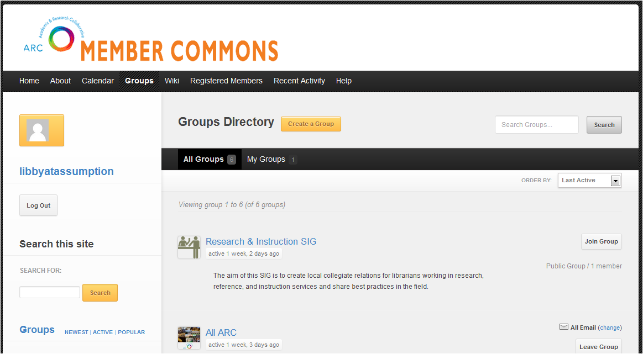

- ENTER A NAME & DESCRIPTION FOR YOUR GROUP/SIG
  - Ideas for description content include:
    - Statement of purpose/goals/tasks your SIG is tackling
    - Name of current Chair
  - Once your name and description are entered, click the yellow “Create Group and Continue” button

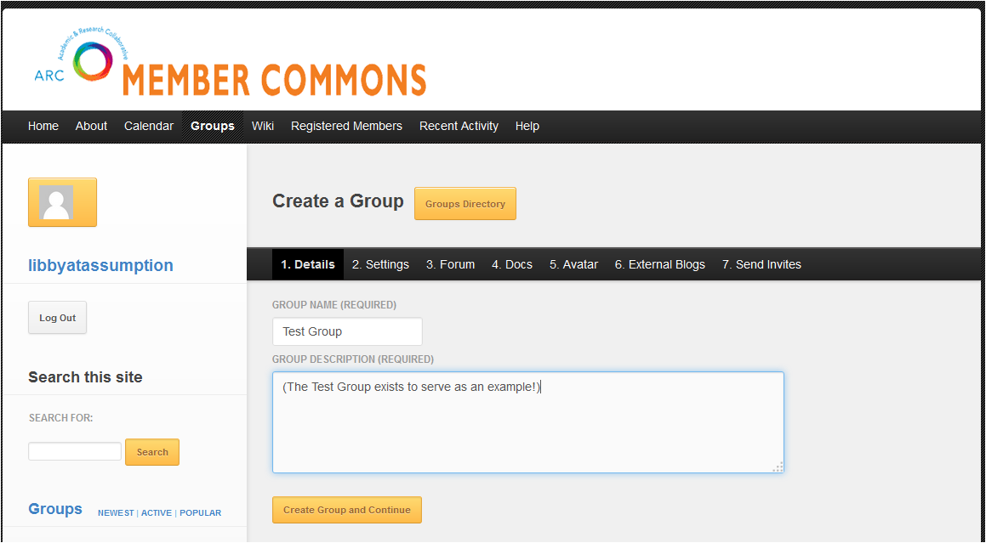

- CHOOSE THE SETTINGS FOR YOUR GROUP
  - Recommended Settings:
    - Privacy Options: “THIS IS A PUBLIC GROUP”
    - Group Invitations: “ALL GROUP MEMBERS”
    - Email Subscription Defaults: “ALL EMAIL” (Individual group members may change this as they wish – this setting is just the default that all new group members will have upon joining.)
  - Then, click the yellow “Next Step” button.
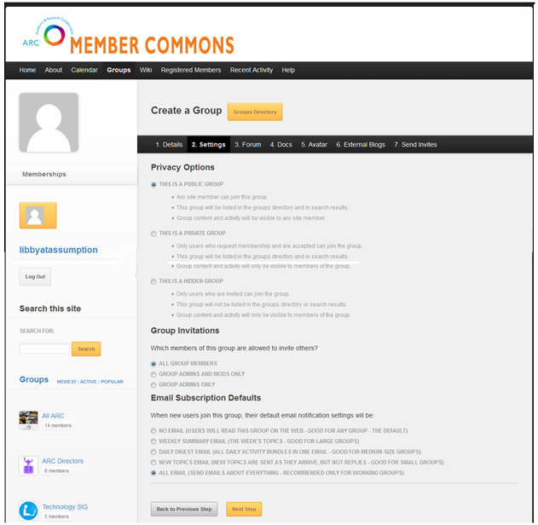

- CREATE A FORUM
  - Simply check the box next to “YES, I WANT THIS GROUP TO HAVE A FORUM”
    - There is no harm in creating a forum and never using it, so do not worry too much about this choice. This way, it will be there if you want it.
    - (There is an explanation of the Forum feature on pages 4-5 of the document “Overview of Groups Functionality” available under “Help.”)
  - Then, click the yellow “Next Step” button.
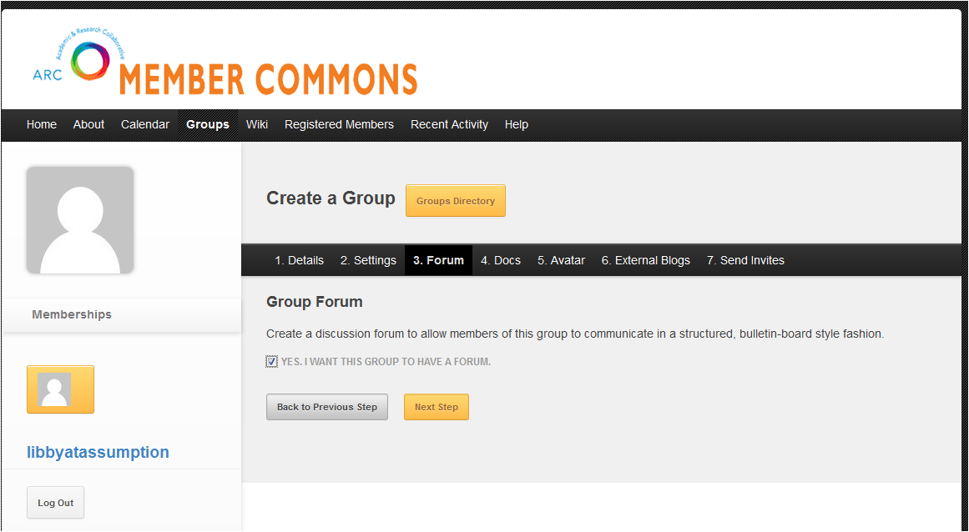

- SET DEFAULT FOR “BUDDYPRESS”
  - Ensure that the box next to “ENABLE BUDDYPRESS DOCS FOR THIS GROUP” is checked
    - “BuddyPress” is what makes the ARC Members portal site interactive and social – it allows registered site members to post comments, and in this case, documents such as meeting minutes, etc., to the website for their entire Group to access.
  - Select the minimum role a registered user of the ARC site must have in order to be able to post a document.
    - Recommended: Group member
  - Then, click the yellow “Next Step” button.
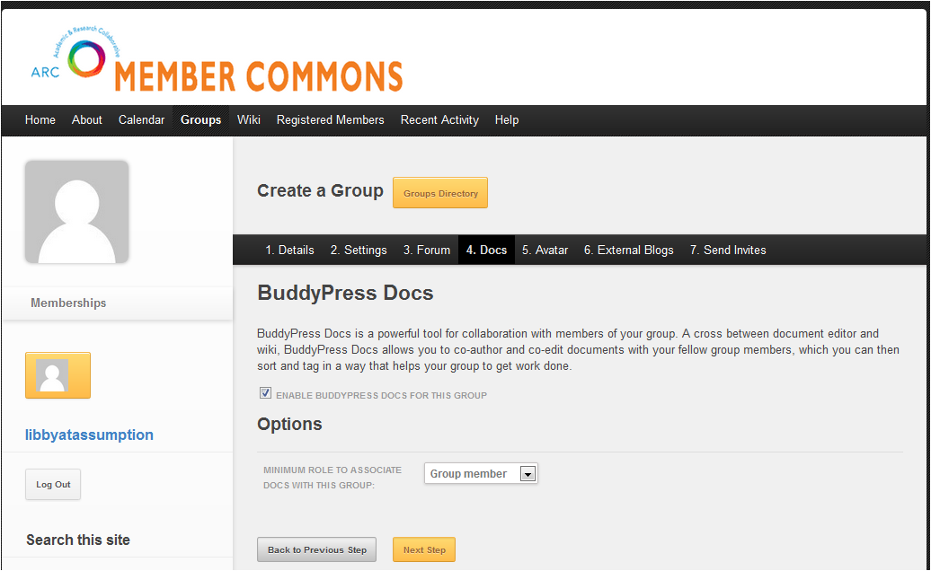

- Upload an avatar photo for your Group
- This step is similar to sending an email attachment, and to uploading an avatar to your personal account:
    - Click on “Browse”
    - Locate the file you wish to use on your computer
    - Click on the green “Upload Image” button
    - (You can always swap this out later if you wish!)
  - Then, click the yellow “Next Step” button.
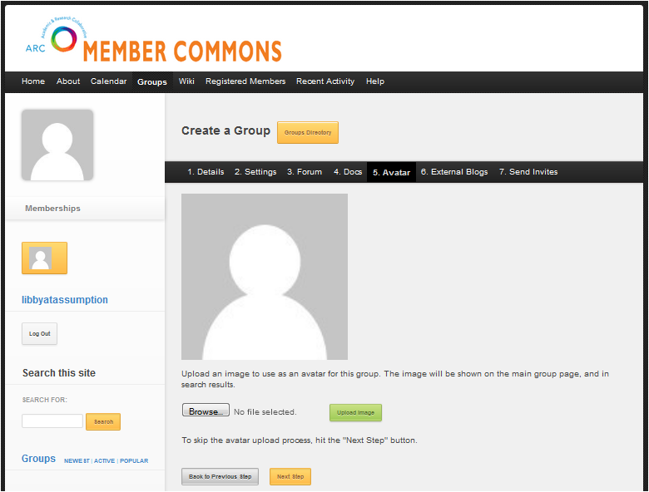

- ATTACH AN EXISTING BLOG
- If your SIG Group has been active for several years, you may have an existing blog that you have used to communicate news. By adding an RSS feed of your existing blog, you may continue to create posts on your established blog, while at the same time feeding news of the new content onto the ARC Members portal site!
  - To link your blog to your Group, simply paste the URL for your blog into the box.
  - If your Group does not have an external blog, you may skip this step entirely.
- Then, click the yellow “Next Step” button.
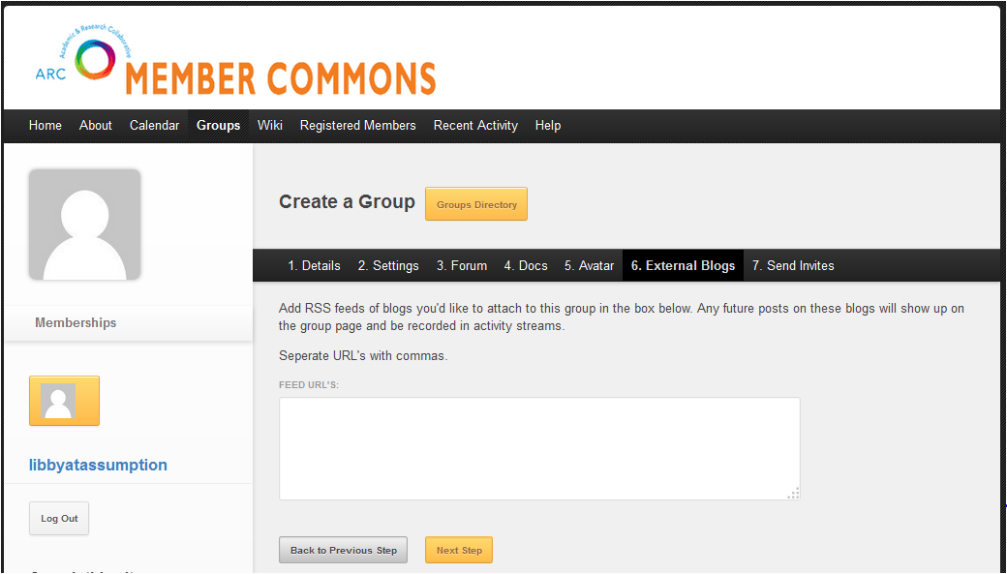

- INVITE MEMBERS TO YOUR GROUP
- Look through the roster of already-registered ARC members for existing members of your SIG Group, or invite others who may be interested:
  - Check the box next to the names of the registered ARC members you wish to invite to join your SIG Group.
  - You may also type the name of an ARC member into the search box to locate and then invite them.
- Then, click the yellow “Finish” button.
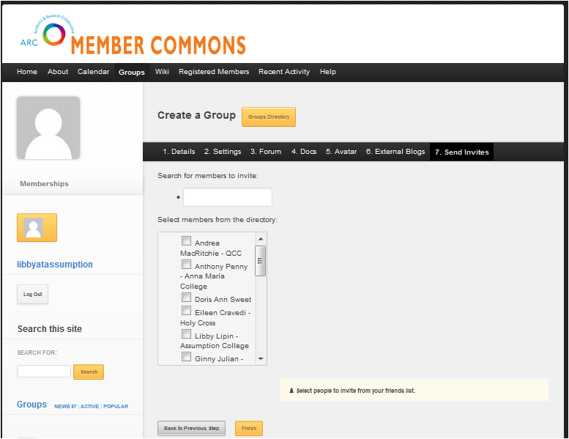

CONGRATULATIONS – YOUR GROUP SET-UP IS COMPLETE!

        - Next, take a look at the functionality of your new Group by taking a look at the document “Overview of Groups Functionality” available under “Help.”

