CREATE AN ACCOUNT TO GET STARTED:
Visit http://www.worcesterarc.org/members/ and follow these 7 EASY STEPS!
IMPORTANT: Please note that emails that come to you from the website have a strange address associated with them. If your institution has a “sensitive” spam filter, you may wish to add the following email address to your “whitelist” or “approved senders” list, etc. right away: worcesu6@box882.bluehost.com
- JOIN
  - Click green JOIN US button on the homepage

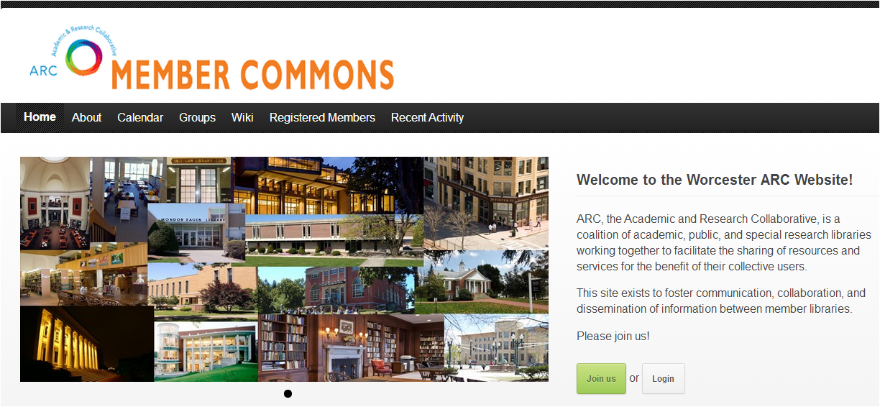

- ENTER YOUR ACCOUNT INFORMATION
  - CHOOSE A USERNAME
    - ***MAKE A NOTE OF THIS! You will need to sign in with your username EVERY time, and it cannot be reset or changed!
    - You may wish to use your email address as your username, as it is simple to remember
  - ENTER YOUR EMAIL ADDRESS:
    - Please use your WORK account if at all possible (It is easier to weed-out spam accounts this way)
  - CHOOSE A PASSWORD
- This can be reset, as long as you have your username!

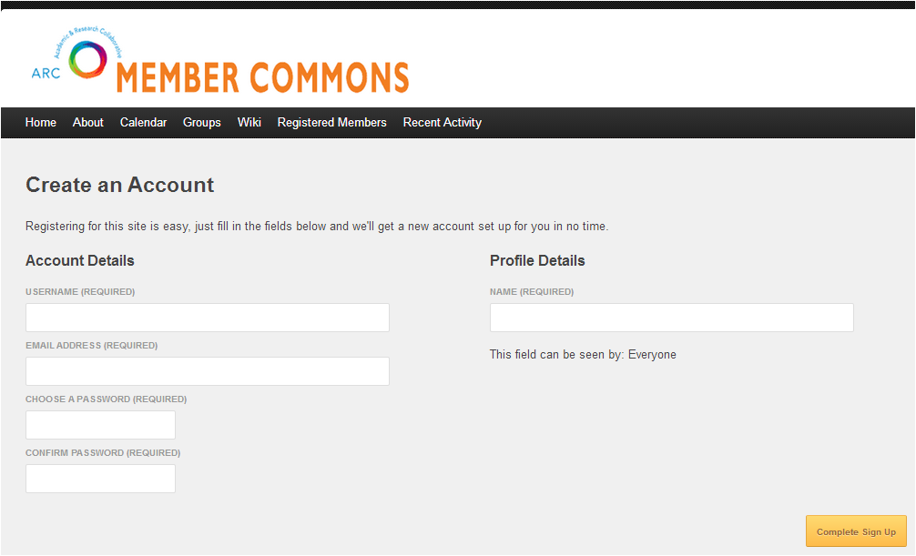

- ENTER YOUR NAME as it will appear to others on the ARC Members website
  - *** PLEASE FOLLOW THIS CONVENTION: First Last – Institution
    - EXAMPLE: Libby Lipin – Assumption College
    - This will help us get to know each other better; connecting a face, name, and ARC library!

- ADD AN AVATAR PHOTO
  - ***PLEASE DO SO RIGHT AWAY (Once again, it is easier to weed-out spam accounts this way, as fake accounts never have a photo associated with them.)
    - Feel free to use a “placeholder” if you do not have an ideal photo readily available; it’s easy to change your avatar again any time.

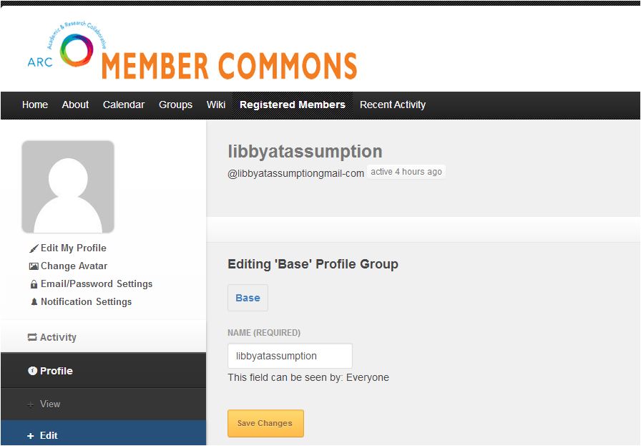

(Directions for this step continue on the next page.)
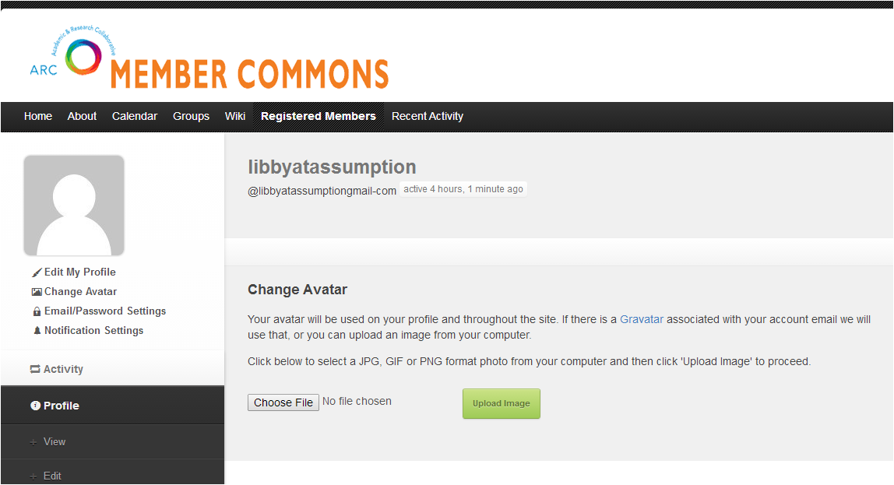

(Click on “CHOOSE FILE,” select an image from your computer, then click on the green “UPLOAD IMAGE” button.)

- CHOOSE YOUR EMAIL SETTINGS, etc.
  - I.e., How often you wish to receive email updates regarding new content to ARC website/SIG groups
    - Wherever an option exists, YES/”ALL MAIL” IS RECOMMENDED
    - You may always change this setting later!

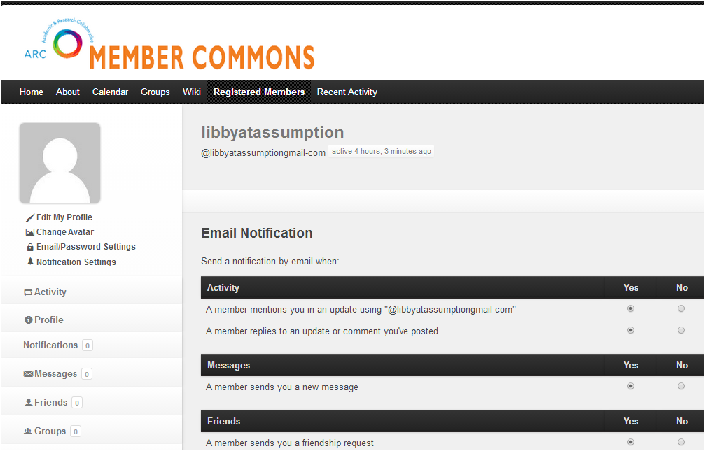

- JOIN THE GROUP ALL ARC
  - Click on GROUPS tab, locate “All ARC” and click the Join Group button.

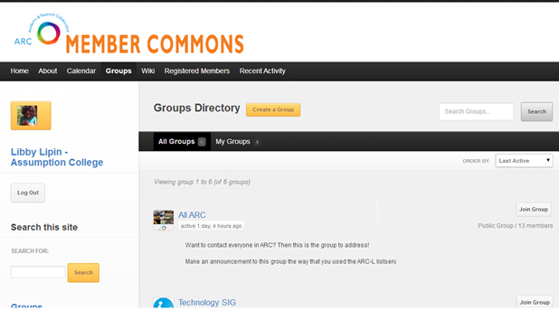

- JOIN ANY OTHER GROUPS YOU WOULD LIKE
  - Don’t see a group for your SIG? Create one!
    - See “Creating a SIG GROUP on the ARC Member Website” for directions and guidelines.
  - Additionally:
    - You may now also “friend” other registered members on the site (wherever you encounter their name, such as when looking at the Members roster for the “All ARC” Group, click on the “Add Friend” button that appears next to it.
    - By clicking on any registered user’s name (whether you have “friended” them or not), you will be able to view their public profile.
      - From this view, you are able to send any member a Private Message, by clicking on this option, which is located in the upper left corner of the page, under their avatar image.

